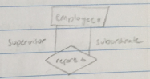

Subclasses

* Subclass = special case = fewer entities = more properties
* Ex: Ales are a kind of beer, not every beer is an ale, but some are.
  + in addition to all the properties of beers, ales also have the attribute of color

ER model: (E-Entities, R – Relationships)

* Entities are usually relevant nouns
  + Stevens has full-time and part-time students
  + Stevens has around 100 faculty members
* Relationships are statements about 2 or more objects
  + A professor teaches a course

Entity-Relationship Diagram

* Entity Set: Collection of similar entities
  + all entities in an entity set have the same set of attributes
  + each entity set has a key (underlined)

Keys of Entities

* Superkey: set of all attributes which, taken collectively, identify uniquely an entity in an entity set
  + set of all attributes of the set is always a superkey
* Key: a superkey for which no proper subset is a superkey (minimal superkey)
  + can be more than one key, but primary key is underlined in ER diagram

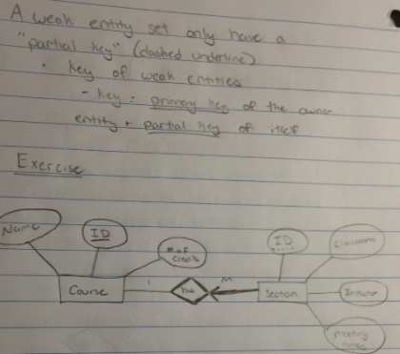

Relationships: Association among two or more entities

* Alan works in Pharmacy dept.

Relationship Set: Collection of similar relationships

Degree of a Relationship: number of participating entities (binary or ternary)

Same Entity Set can participate more than once in the same relationship with different “roles” (recursive relationship):  
Shapes:

* Rectangles: entity sets
* Diamonds: relationship sets
* Lines: link attributes to entity sets and entity sets to relationship sets
* Ovals: attribute of entity/relationship sets
* Underline: indicates primary key attributes

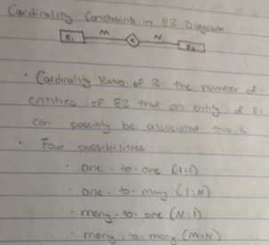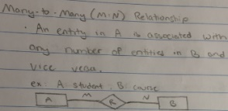

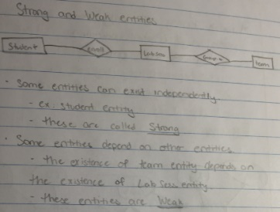

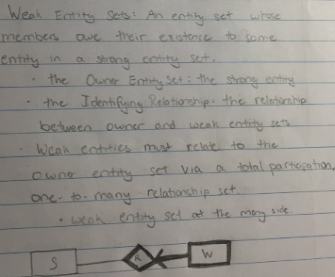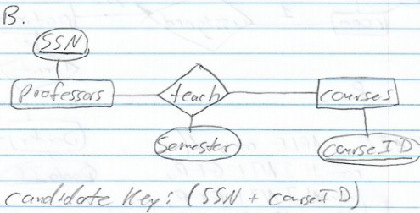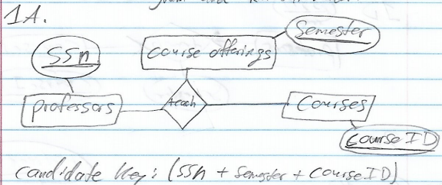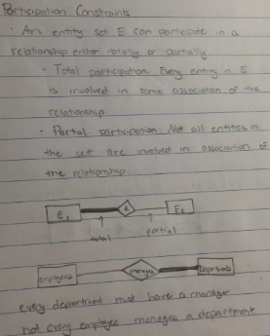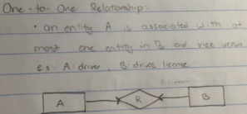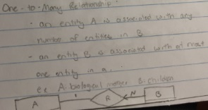

A university DB contains information about professors (identified by SSN) and courses (identified by course ID). Professors teach courses; each of the following situations concerns the Teaches relationship set.

For EACH situation in (a) and (b) below, draw an ER diagram that describes it, and list all candidate keys of the Teaches relationship set.

(a) Professors can teach the same course in several semesters, and each offering must be recorded [10pts].

(b) Professors can teach the same course in several semesters, but only the most recent offering is recorded [10pts].

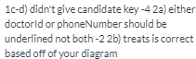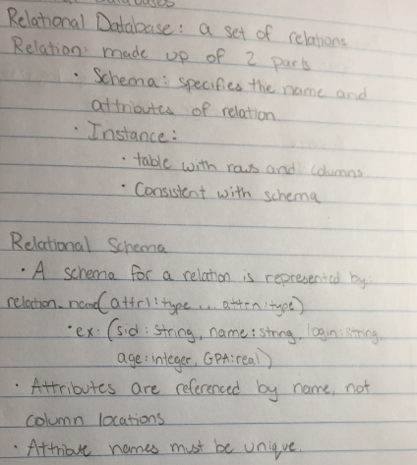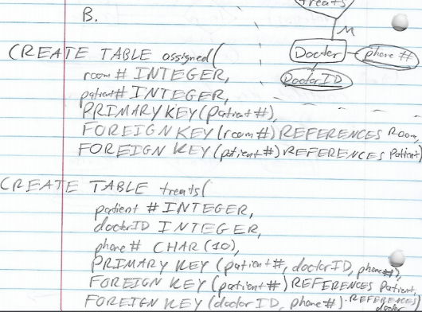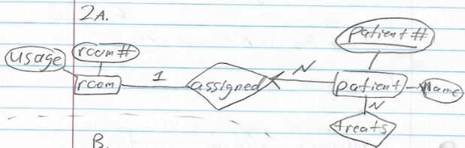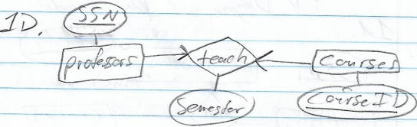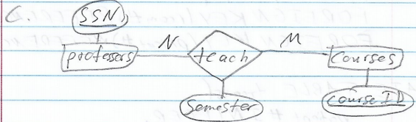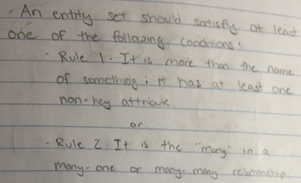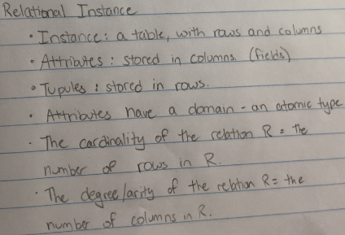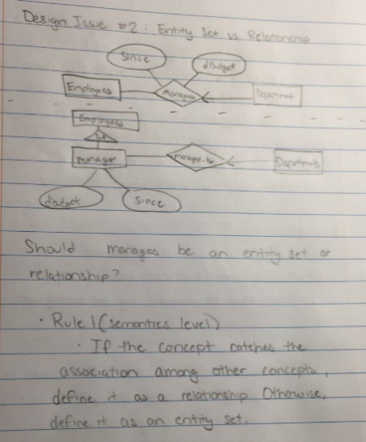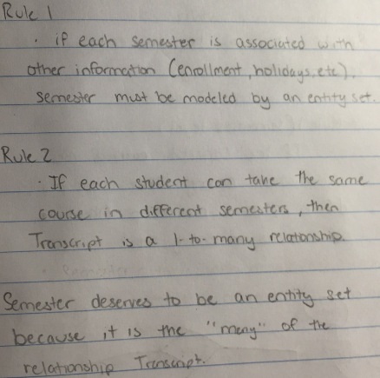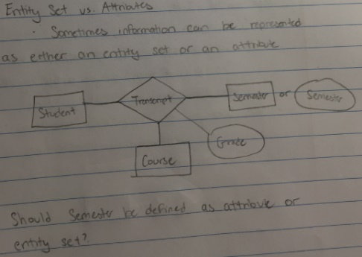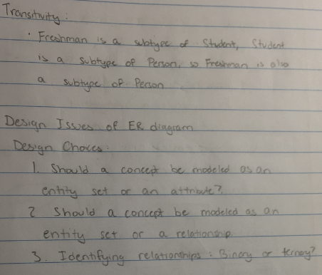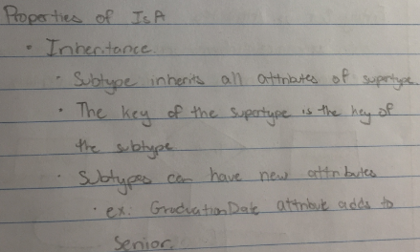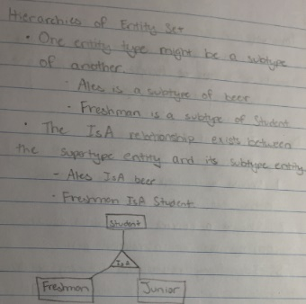

You are hired to set up a relational database for a small community hospital. Below are the facts of the hospital’s data.

* Every room has a unique room number (integer);
* Every room has one designated usage (char [40]), but different rooms may have the same usage;
* Every patient is assigned a room. Multiple patients may be assigned to the same room;
* Every patient has a unique patient number (integer);
* Every patient has a name (char[40]) which is not necessarily unique;
* A patient may be treated by more than one doctor, and a doctor may attend to more than one patient;
* Every doctor has a unique doctor ID (integer) and a unique phone number (char[10]).

(b) Professors can teach the same course in several semesters, but only the most recent offering is recorded [10pts].

Assume the above Situation (b) applies in all subsequent situations.

(c) Each professor teaches at least one course, and each course is taught by at least one professor [10pts].

(d) Every professor teaches exactly one course, and every course is taught by exactly one professor [10pts].